

Year 12 Chemistry
Organic Chemistry Test

Time allowed: 45 minutes

Name:___________________________________

Marks: ___________ / 45

Teacher: CEM NMO DGM JPT

Section 1: Multiple Choice Questions

- Which one of the following substances would you expect to have the highest boiling point?

- CH₃CH₂ CH₂CH₂OH
- C(CH₃)₄
- CH₃CH₂CH₂ CH₂CH₃
- CH₃COCH₂CH₃

- Which functional groups are present in the following compound?
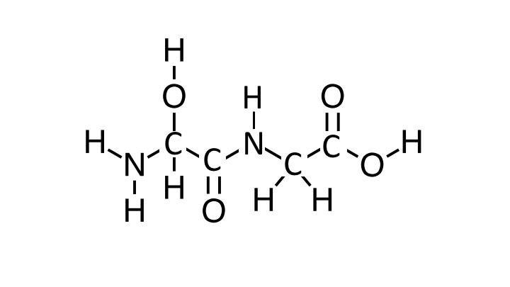

- A carboxylic acid, two amines, an alcohol and a ketone
- A carboxylic acid, an amine, an amide, and an alcohol
- Two ketones, two amines, and two alcohols
- A carboxylic acid, an amide and an alcohol

- Which of the following bonds/interactions are responsible for the secondary structures of proteins?

- The intermolecular forces between side chains of amino acids, including ion-dipole, dispersion forces, dipole-dipole attractions and hydrogen bonds.

- The non-covalent interactions between the different polypeptide subunits that make up a multi-unit protein complex

- The hydrogen bonds between the amide C=O and N-H on the peptide backbone.

- The C-N peptide bonds between adjacent amino acids in a polypeptide chain.

- Which of the following pairs of compounds could be most readily distinguished by the addition of acidified potassium permanganate:

- Propanone and propanoic acid
- Propanal and propan-1-ol
- Propan-2-ol and propan-1-ol
- Propanone and propanal

- To synthesize methyl propanoate, one would react which of the following in acidic conditions:

- Propan-1-ol and methanoic acid
- Methanoic acid and propane
- Methanol and propanoic acid
- Methane and propan-2-ol

- Below is a section of a polymer.
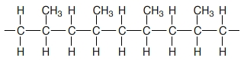

Which of the following are the monomer(s) from which the polymer is formed?

- Methane and ethene
- Propene
- Propane
- Propene and ethane

- The following ester is hydrolysed in the presence of NaOH.

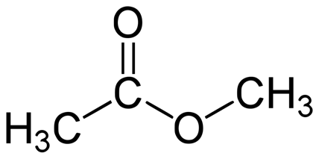

Which of the following correctly lists the two products of this hydrolysis reaction?

- Methanol and sodium ethanoate
- Methanol and ethanoic acid
- Ethanol and methanoic acid
- Ethanol and sodium methanoate

- Which of the following compounds have the same empirical formula?
- Ethanoic acid | - Ethanol
- Methyl methanoate | - Ethyl ethanoate
- Ethanal | - Propanone

- I, II and V
- I and III
- V and VI
- None of the above

- Which of the following statements is false?

- Amino acids polymerise to form long polypeptide chains joined by amide linkages
- Ethene undergoes an addition reaction with bromine to form 1,1 dibromoethane
- Polyamides and polyesters are both examples of condensation polymers
- Cyclobutane and cis-but-2-ene have the same empirical formula

- Which of the following compounds would you expect to be the least soluble in water?

- Propane
- Hexane
- Propanol
- Hexanal

Section 2: Short Answer Section:

Question 1 6 marks
Give the name and structural formula of the main organic product(s) for the following reactions:

 | Reaction | Structural Formula of the main organic product(s) | Name of the main organic product(s)
a) | Excess acidified potassium dichromate is added to propan-2-ol
b) | Bromine water is added to cis-but-2-ene
c) | Chloroethene forms an addition polymer. Draw a section of the polymer containing 3 monomer units  NB. No name is required
(6 marks)

Question 2 9 marks

Give a chemical test that could be used to distinguish between the following two chemicals. Describe any observations.

- Propanoic acid and Propanone

Chemical test: _____________________________________________________________________

Observations:
Propanoic acid | Propanone
(3 marks)

- Pentan-1-ol and 2-methyl butan-2-ol

Chemical test: _____________________________________________________________________

Observations:
pentan-1-ol | 2-methyl butan-2-ol
(3 marks)

- Pentan-1-ol and 2-methyl butan-2-ol can also be separated by physical means, using differences in their boiling points. Predict which compound will have the higher boiling point and explain your response.

____________________________________________________________________________________________________________________________________________________________________________________________________________________________________________________________________________________________________________________________________________________________________________________________________________________________________________________________________________________________________________
(3 marks)

Question 3 3 marks

Below is a section of a polymer, showing 2 repeating units.

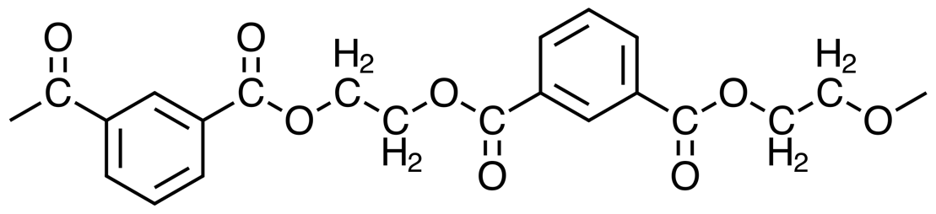

- To which class of polymer does this compound belong? (1 mark)

_________________________________________________________________________________

- Draw the two monomer units that were used to form this polymer.

Monomer 1 | Monomer 2
(2 marks)

Question 4 4 marks

Aspartame is an artificial sweetener also known as Equal or Splenda. It was discovered by accident in 1965 by a scientist wanting to synthesise a tetrapeptide for another purpose, when he licked his finger to pick up a piece of paper. It is a methyl ester of the dipeptide Asp – Phe.

- Draw the structure of the dipeptide Asp-Phe as it would exist under strongly acidic conditions.

(2 marks)

- Aspartame is formed when methanol is reacted with the dipeptide Asp - Phe under acidic conditions. It is a monoester, not a diester. Using this information, draw the two possible structures for aspartame in the space below.

Structure 1

Structure 2

(2 marks)
Question 5 3 marks

The tertiary structure of a protein can involve many different types of interactions. If the four amino acids shown below are found in close proximity on the same polypeptide chain, state the dominant type of interaction that would exist at pH 7 between the side chains of the amino acids listed.

Phenylalanine  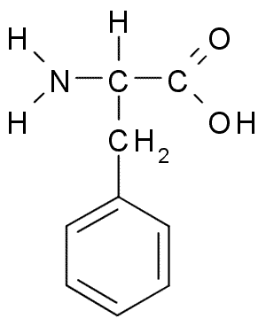 | Serine  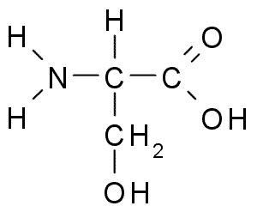
Threonine  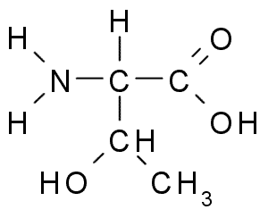 | Cysteine  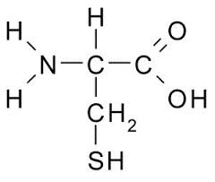

- Serine and threonine

___________________________________________________________________________

- Phenylalanine and Serine

___________________________________________________________________________

- Cysteine and Serine

___________________________________________________________________________
(3 marks)

Question 6 10 marks

Fats are triglyceride molecules containing 3 ester groups. They can used as precursors to produce both soaps and biodiesel. Glycerol is produced as a by-product in both synthetic reactions.

- Write balanced reactions in the space below to show how the tristearin molecule below (a fat) can be used to produce both a soap and biodiesel.

Soap

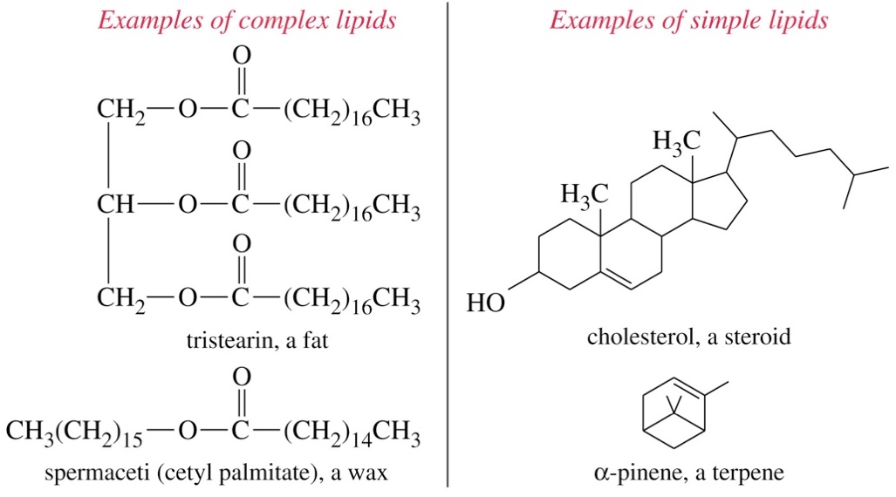

+

Biodiesel



+

(6 marks)

- Detergents and soaps share many structural similarities that enable them to act as cleaning agents. Sodium dodecyl sulfate (CH₃(CH₂)₁₁OSO₃⁻) is a commonly used detergent and its structure is shown below:

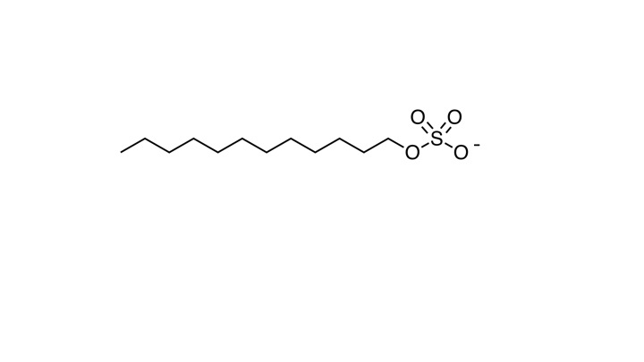

- Discuss the similarities in the structures of soaps and detergents that enable them to remove oil and grease from surfaces

__________________________________________________________________________________________________________________________________________________________________________________________________________________________________________________________________________________________________________________________________________________________________________________________________________________________
(2 marks)
- Soaps are less effective than detergents when used in hard water. Explain this observation

__________________________________________________________________________________________________________________________________________________________________________________________________________________________________________________________________________________________________________________________________________________________________________________________________________________________
(2 marks)

